# COMM FILTER

* Comm file1 file2 : comm command is basically the compare command, this command always gives results in 3 different columns.

1. Where, the first column gives the information that is present in 1st file but not in 2nd file.
2. The second column gives the information present in 2nd column but not in the first column.
3. The third column give the information present commonly present in both the files.

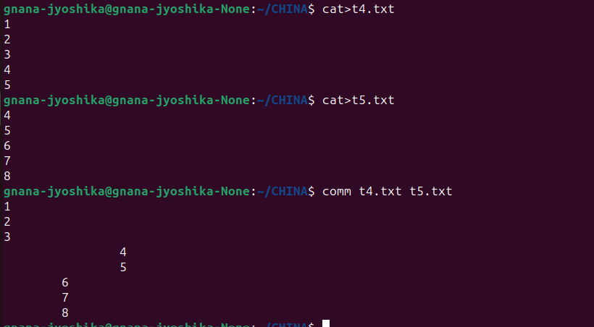

* If you wanted to just print individual columns, you can do that as well

1. comm -23 file1 file2 : It displays the information present in the 1st file but not in the 2nd file.



1. comm -13 file1 file2 : It displays the information present in the 2nd file but not in the 1st file.

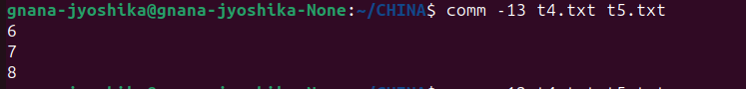

1. comm -12 file1 file2 : It displays the information present commonly in both the 1st and 2nd files.

